**Q1** Write a program to calculate the sum of first 10 natural number.

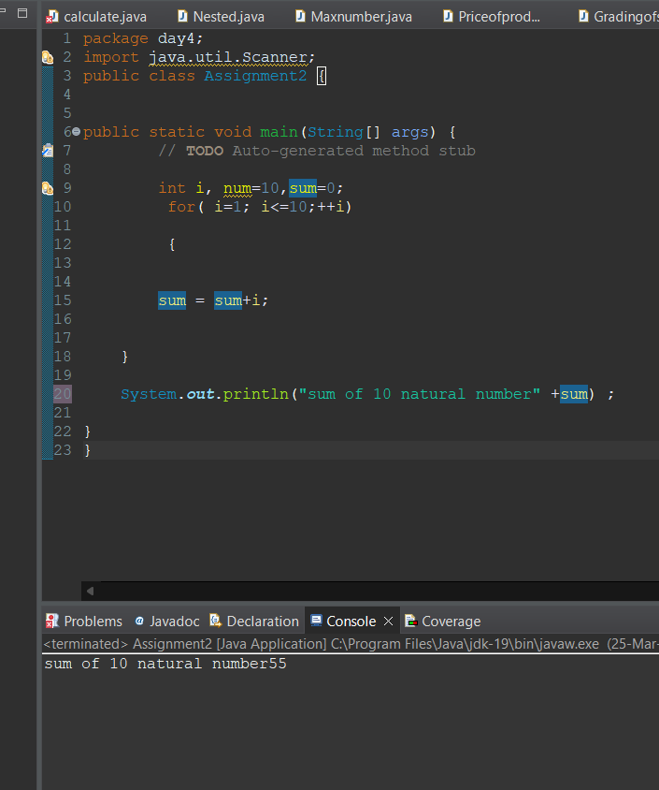

**Q 2** Write a program that prompts the user to input a positive integer. It should then print the multiplication table of that number.

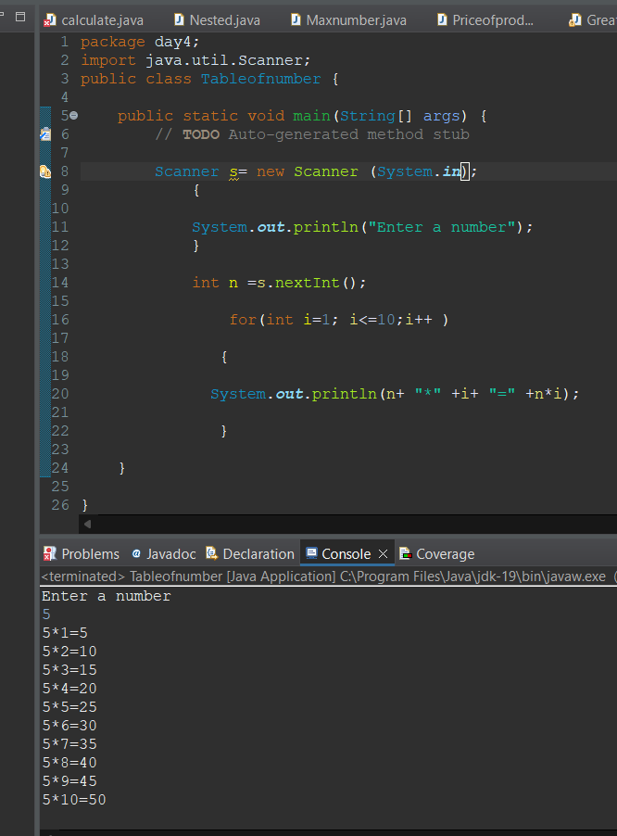

**Q 3** Write a program that prompts the user to input an integer and then outputs the number with the digits reversed. For example, if the input is 12345, the output should be 54321.

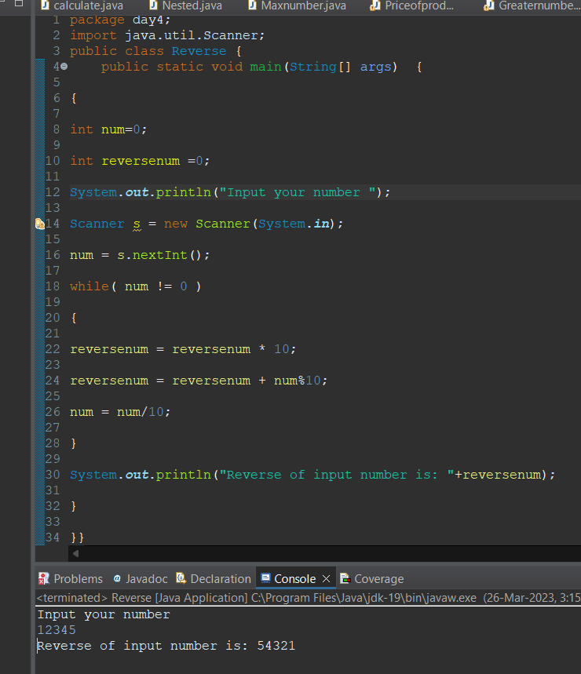

**Q4** Write a do-while loop that asks the user to enter two numbers. The numbers should be added and the sum displayed. The loop should ask the user whether he or she wishes to perform the operation again. If so, the loop should repeat; otherwise it should terminate.

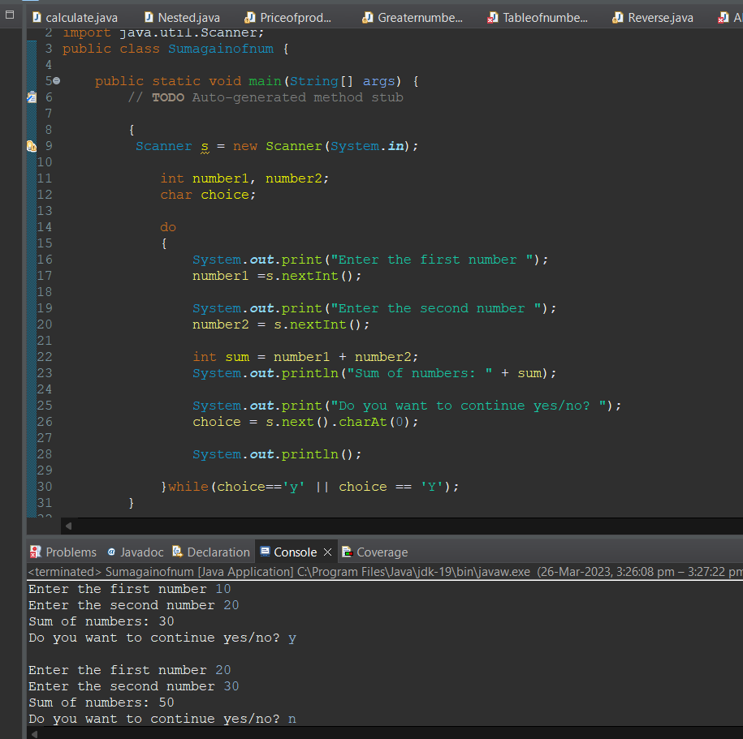

**Q5** Write a program to print out all Armstrong numbers between 1 and 500. If sum of cubes of each digit of the number is equal to the number itself, then the number is called an Armstrong number.  
For example, 153 = ( 1 * 1 * 1 ) + ( 5 * 5 * 5 ) + ( 3 * 3 * 3 )

**Q 6** Write a program to print Fibonacci series of n terms where n is input by user :  
0 1 1 2 3 5 8 13 24 .....

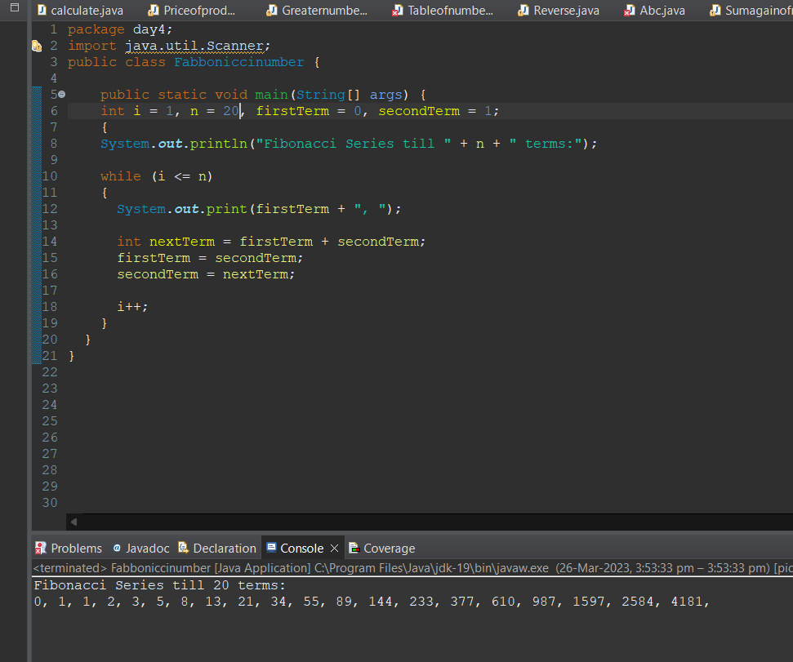

Q7 Write a program to print following :

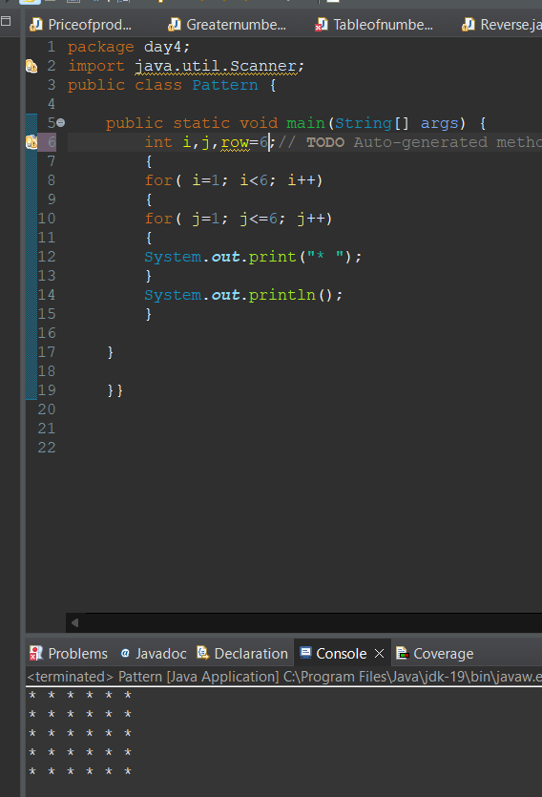

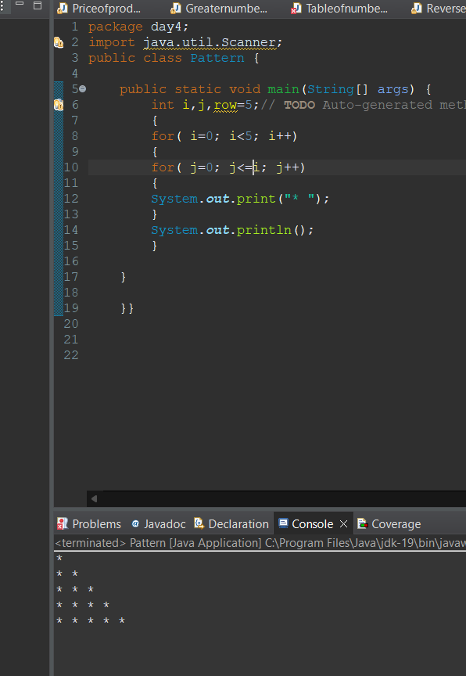

iii)

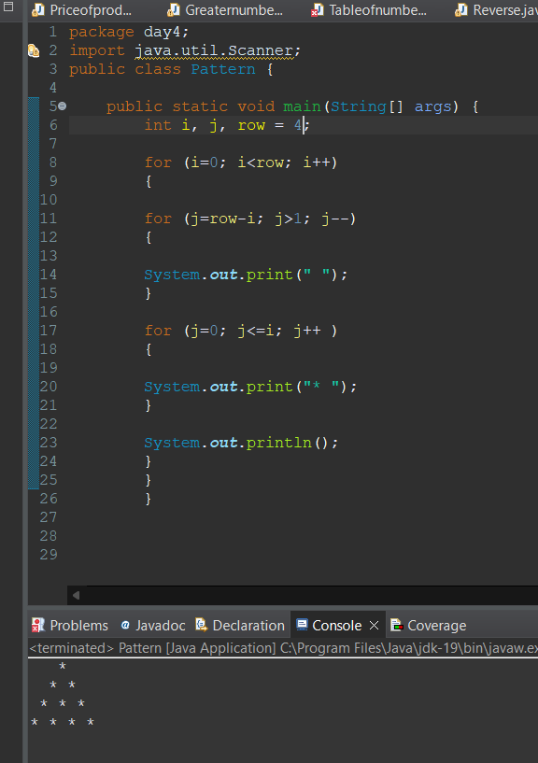

iv)

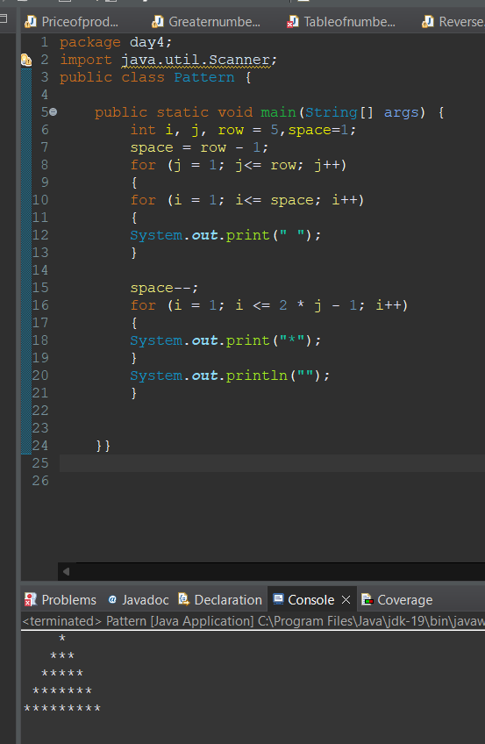

v)

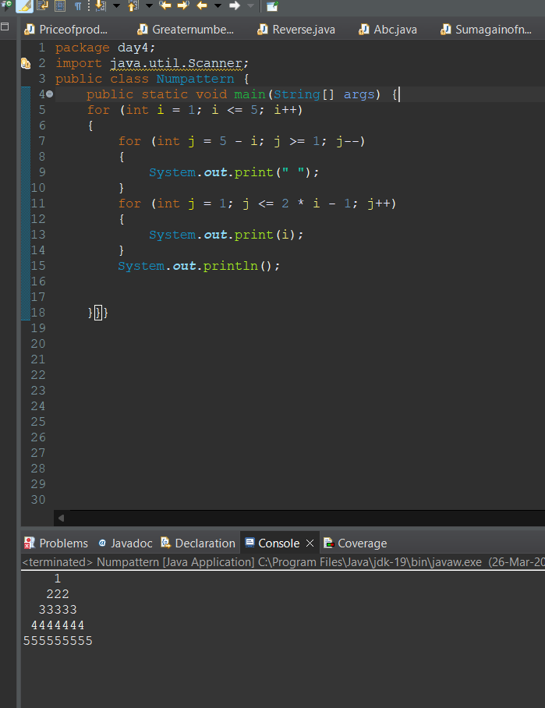

vi)   ABCDEEDCBA  
         ABCD  DCBA  
         ABC      CBA  
         AB         BA  
         A             A